Courtney Thurston

AP Art History

Mrs. Eckel

U3L3 Art of Ancient Greece II

*Select one work of art from the flashcards for Gallery 3 you feel best exemplifies this gallery based on what you have learned this far. Explain which art you selected and why.*

*Important points to include: Fully identify your selected image; Include your reasons for selecting this image—key ideas; Support your selection with specific examples that connect contextual and visual elements.*

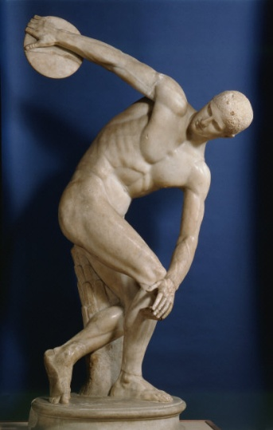

I selected an image of the Discus Thrower Diskobolos by the artist Myron, circa 450 B.C.E. I selected this art because it shows the naturalistic form of the human body, engaged in a sporting activity. It is a restrained pose in that it captured the person just before release of the discus, and yet it is motion personified. As such, the figure represents the potential of human nature represented in the Greek ideals. The figure is realistic and portrays movement and activity, yet it is bounded and is on the verge of achievement. I like that it displays an everyday type of figure, which Greek art and sculpture later developed to depict (for example "seated boxer").